ECE 441 Fall 2021

WEEK #14 GROUP MEETING LOG

Lab Session: 2

Group Number: 2

Instructor: Dr. Jafar Saniie

Due Date: 04-20-2022

Acknowledgment: I acknowledge all of the work (including figures and codes) belongs to me and/or persons who are referenced.

Member 1: Alan Palayil

Member 2: Fabian Garcia

Member 3: Gabriel Gutierrez

[Smart Mirror - *Through a Speculum*]

**Project Goal:**

* Create an interactive smart mirror with gesture control, voice commands, and possibly facial recognition.
* Include accessories like LED strips and a sound system.
* Design a compacted design for the 24inch display

**Standards used in Project:**

Not applicable during this stage of the project

**System Constraints:**

* Working around the android 11/12 OS
* Limited to installing and design app

**Prior Knowledge Acquired Critical to Design Project:**

ECE 100, ECE 211, ECE 213, ECE 218, ECE 242, ECE 307, ECE 308, ECE 311, ECE 319, ECE 407, ECE 411, ECE 436, ECE 438, ECE 485, CS 115, CS 116, CS 330, CS 331, CS 350, CS 351, CS 450

Note:

CS 331- Data Structures and Algorithms (Python Programming)

ECE 411: Power Electronics

Meeting 1

| Date | 4/16/2022 |
| --- | --- |
| Start Time | 1:00 PM |
| Duration | 2-hour |
| Attendance | All attended |

1. **Agenda**

The team decided to name the project Through the Speculum to Through a Speculum, TAS for short

The purpose of this meeting was to work on the final presentation and report. Using the Decibel Display project report, we created an acceptable format and began adjusting it to fit our design and constraints.

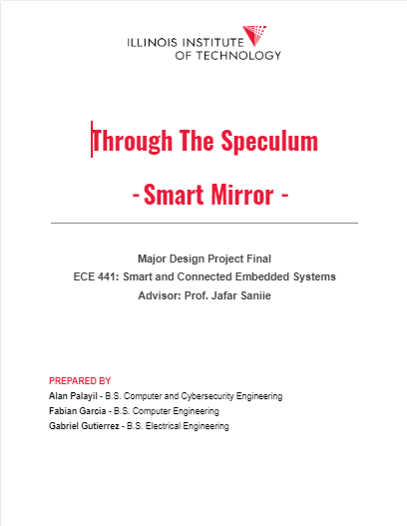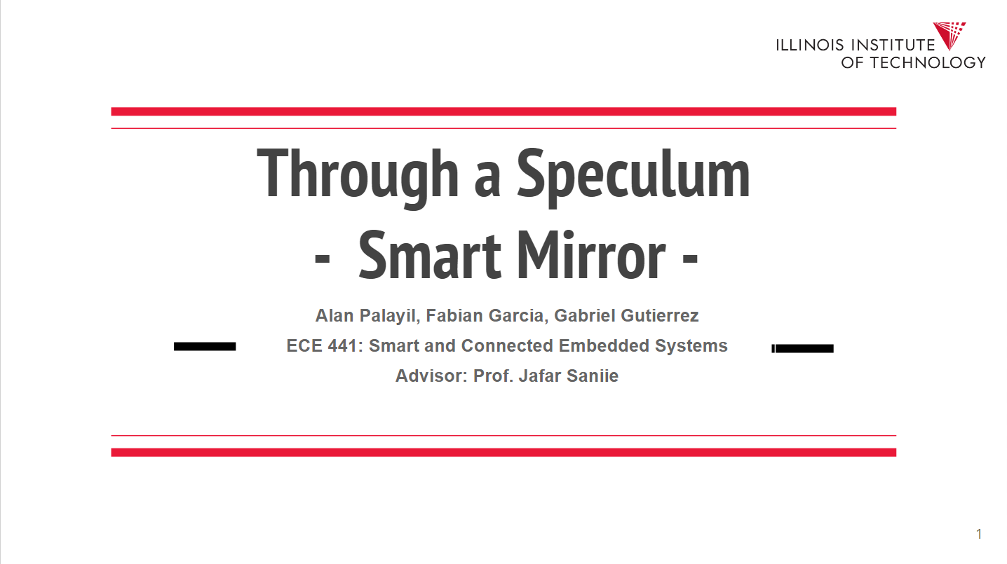

* We discussed what topics would be relevant to our final presentation and video.
* We assigned each other sections that need to be completed

Talked about the main assembly and what still needs to be done.

1. **Tasks**

| **1 - Idea development** | | |
| --- | --- | --- |
| **Task** | **Assigned to** | **Due Date** |
| Continue on the report and presentation | Everyone | April 28 |
| Find a security system app | Gabriel | Tuesday 19 |
| Work on widgets | Fabian | Tuesday 19 |
| User Interface | Alan | Tuesday 19 |

1. **Work Distribution**

| **Alan Palayil** |  |
| --- | --- |
| **Fabian Garcia** |  |
| **Gabriel Gutierrez** | Decided to focus on the hardware portion of the report and will work to finalize finding a security system app. |

1. **Progress and Milestones**

The enclosure has been laser cut and is ready for assembly

1. **Next Steps**

The team will hold on next meeting on Tuesday at 9AM. This will be to finalize the main assembly

Meeting 2

| Date | 4/19/2022 |
| --- | --- |
| Start Time | 9:00 AM |
| Duration | 3 hour |
| Attendance | All attended |

1. **Agenda**

This meeting was used to do the main assembly, and work on our demo videos

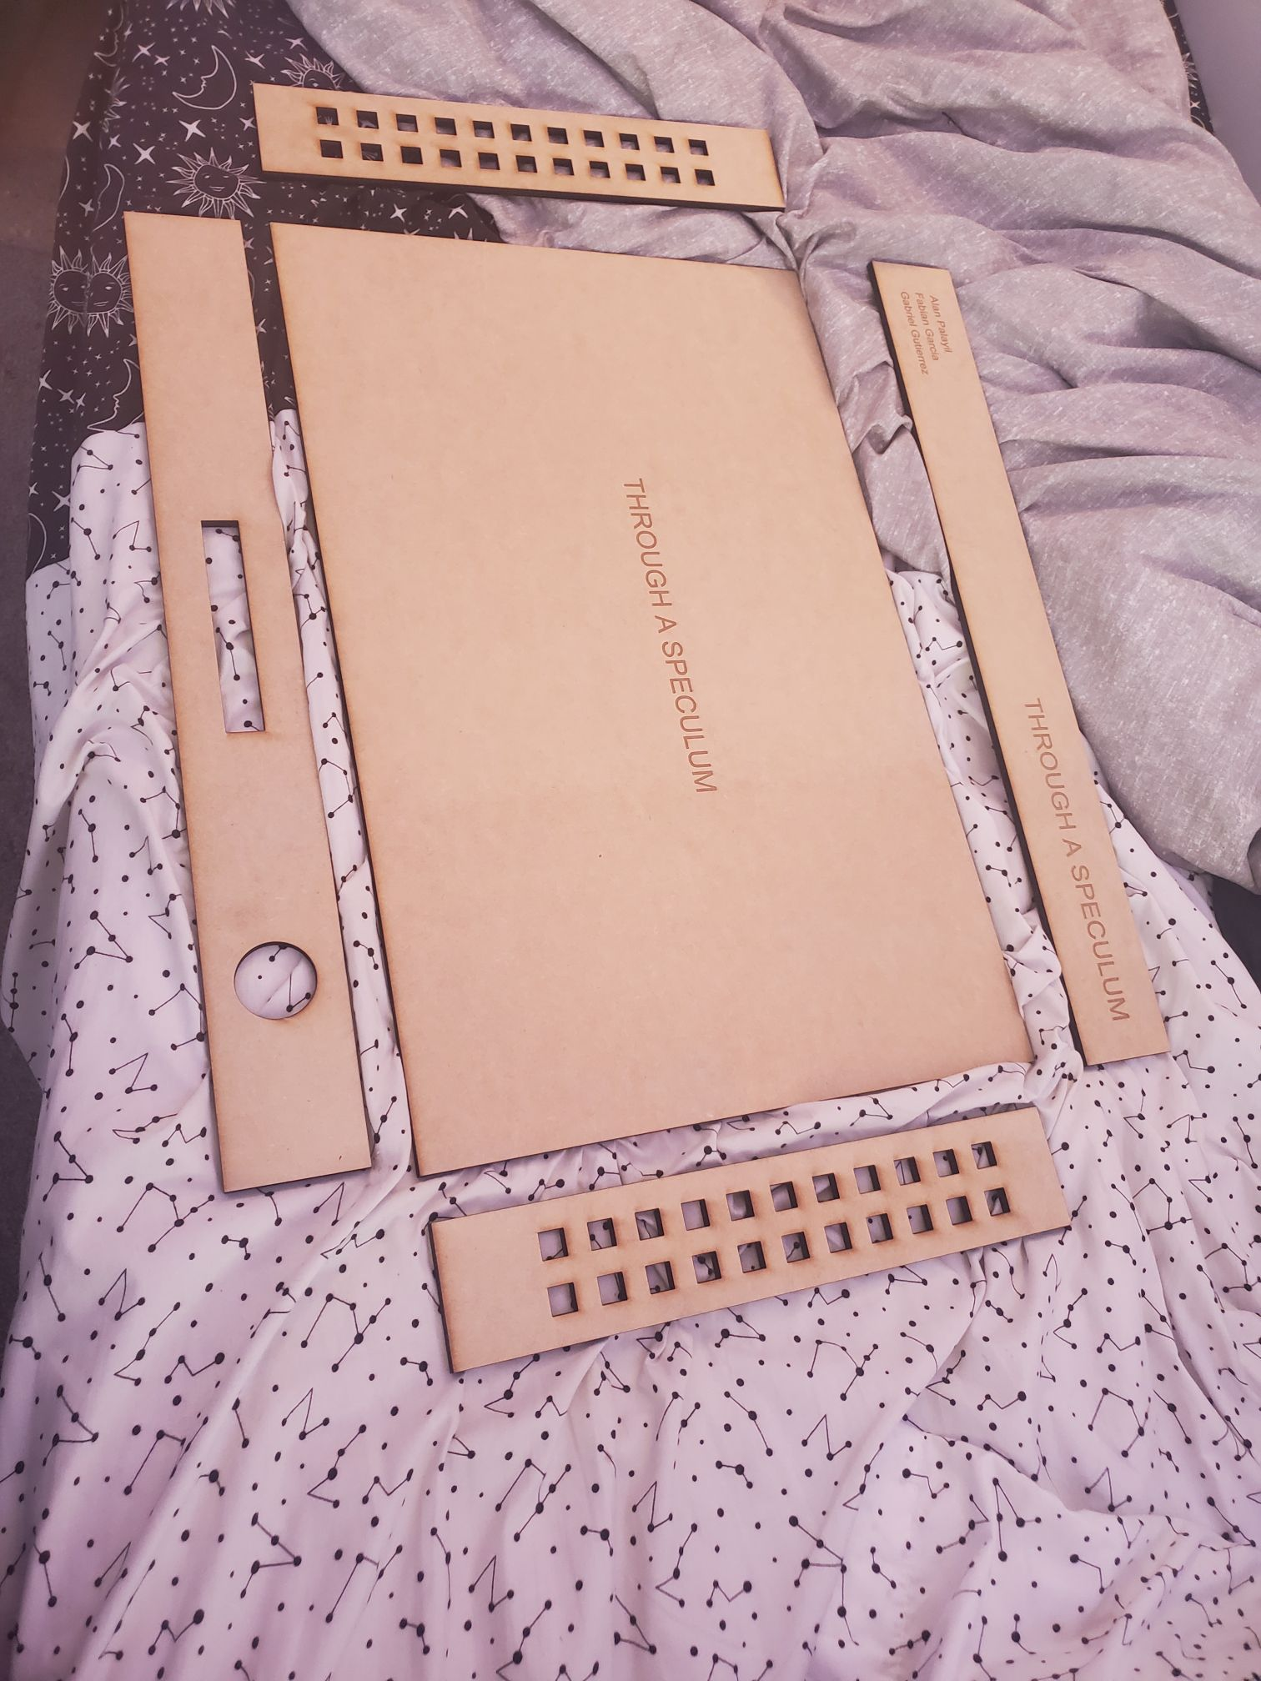

1. **Tasks**

| **1 - Idea development** | | |
| --- | --- | --- |
| **Task** | **Assigned to** | **Due Date** |
| Finish Report, Presentation, and video | Everyone | April 28 |

1. **Work Distribution**

| **Alan Palayil** | Worked on assembly and report |
| --- | --- |
| **Fabian Garcia** |
| **Gabriel Gutierrez** |

1. **Progress and Milestones**

Finished assembling project

1. **Next Steps**

The next steps are to finalize the final presentation and video.